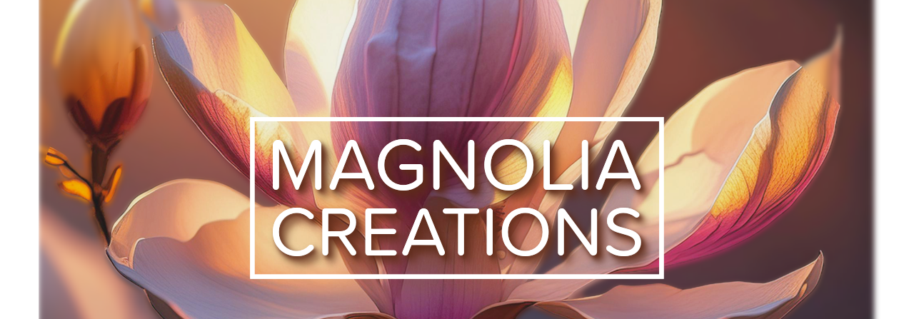
Clear communication keeps everyone prepared—and when clocks shift, that’s more important than ever. This Attendee Copy provides ready-to-send language you can drop into your pre-event emails, registration confirmations, or mobile app alerts. It’s designed to help guests arrive on time, well-rested, and ready to engage—no missed sessions and no sleepy starts.
👥 Attendee Copy (Sample Messaging)
Subject: Time Change This Weekend ⏰ — Don’t Miss the Opening Session!
Friendly reminder: Daylight Saving Time ends this weekend! Please set your clocks back one hour before Sunday.
Our sessions begin promptly at [Event Start Time] on [Date]. We’ll have coffee and breakfast ready [if applicable] for the early risers — and plenty of energy to kick off an amazing day together.
Safe travels and see you bright and on time!
— The [Event Name] Team
Tip: Enable automatic time-zone updates on your phone to avoid confusion between travel and home zones.
A clear, friendly reminder goes a long way. Use this copy to keep guests informed, reduce day-of confusion, and show the attention to detail that sets your events apart. Communication is one of the simplest ways to elevate the guest experience—and one your attendees will always appreciate.

